Total and Ionised Calcium Status in Children Aged 1–5 Years Hospitalised with Lower Respiratory Tract Infection: A Single-Centre Cross-Sectional Audit (Synthetic Teaching Dataset)
**Authors.** [TO BE FINALISED]
**Affiliations.** [TO BE FINALISED]
**Corresponding author.** [TO BE FINALISED]

Abstract
**Background.** Hypocalcaemia is variably reported in paediatric lower respiratory tract infection (LRTI), and total and ionised calcium are commonly used interchangeably without rigorous within-cohort comparison. We quantified the prevalence of hypocalcaemia by both definitions, their concordance and continuous agreement, and tested age as a predictor.
**Methods.** Single-centre cross-sectional audit of a synthetic teaching dataset (n = 100 children aged 1-5 y, all labelled with LRTI). Pre-specified 7-test plan: reference-range comparison (Shapiro-Wilk → t / Wilcoxon, BH-FDR), prevalence (Wilson 95 % CI), Cohen's κ, Pearson + Spearman + OLS, Bland-Altman (mg/dL primary; z-score secondary), age-stratified Kruskal-Wallis, and logistic regression with a CV-AUC < 0.65 non-deployment gate.
**Results.** Hypocalcaemia by total calcium occurred in 25.0 % (95 % CI 17.5-34.3); by ionised calcium in 26.0 % (95 % CI 18.4-35.4). Cohen's κ was 0.97 (almost perfect). Pearson r was 0.77 (R² 0.59). Ionised calcium fell below the centre of its reference interval (Wilcoxon, q-FDR < 0.001); total calcium did not. Both age-only logistic models were non-deployable on cross-validation (CV-AUC = 0.47 and 0.53) and fell below the pre-specified threshold (CV-AUC ≥ 0.65).
**Conclusions.** On this synthetic cohort, the two definitions of hypocalcaemia were operationally interchangeable for case-finding (κ ≈ 0.97) but not for continuous quantification (R² ≈ 0.59). Age alone did not predict hypocalcaemia within the 1-5 y window. External validation in real cohorts is required before any clinical deployment.
**Keywords.** paediatric, hypocalcaemia, lower respiratory tract infection, ionised calcium, total calcium, Bland-Altman.

Introduction
Lower respiratory tract infection (LRTI) is a leading cause of paediatric morbidity worldwide. Biochemical disturbances such as hypocalcaemia have been described variably across settings, with reported prevalences ranging widely depending on the laboratory definition used (total versus ionised calcium) and on the cut-off applied. Ionised calcium is the physiologically active fraction, but total calcium is more widely available; the two are commonly used interchangeably in paediatric practice without rigorous within-cohort comparison.
We pre-specified seven analyses on a single-centre cross-sectional cohort of children aged 1-5 y with LRTI: (i) cohort prevalence by each definition, (ii) the agreement between the two binary definitions, (iii) the strength of the underlying continuous relationship, (iv) the difference of each variable from the centre of its published paediatric reference interval, (v) age-stratified patterns, and (vi-vii) a deliberate test of whether age alone discriminates between hypocalcaemic and normocalcaemic patients within the 1-5 y window. We report all seven findings, including the negative ones.

Methods
**Design and dataset.** Single-centre cross-sectional audit of a synthetic teaching dataset (n = 100 paediatric records, ages 1-5 y, all labelled with a diagnosis of lower respiratory tract infection). The dataset and analysis configuration are publicly hosted; no human subjects were studied.
**Pre-specified findings.** 7 findings were registered in a pre-specified findings ledger before any inferential test was performed. The full ledger (with ranking rule, evidence-section pointers, and clinical interpretations) is in `staged/01_findings_ledger.md`. All test choices, thresholds and CI methods were fixed before the analysis ran.
**Statistical approach.** Pre-specified 7-test plan: reference-range comparison (Shapiro–Wilk → t / Wilcoxon, BH-FDR), prevalence with Wilson 95 % CIs, Cohen's κ, Pearson + Spearman + OLS, Bland-Altman (mg/dL primary via OLS-inverse, z-score secondary), age-stratified Kruskal-Wallis (+ ANOVA when n_band ≥ 5), and logistic regression with a pre-specified CV-AUC < 0.65 non-deployment gate. Implemented in scipy.stats / statsmodels / scikit-learn / numpy / pandas. No survival analysis was performed.

Tables
**Table 1.** Cohort baseline characteristics (n = 100).
Characteristic | Value
Age, mean (SD), y | 2.999 (1.1276)
Age, median (IQR), y | 3.1 (2.2–4.0)
Age range, y | 1.0–5.0
Total calcium, mean (SD), mg/dL | 9.5001 (1.2172)
Ionised calcium, mean (SD), mmol/L | 1.1266 (0.1363)
Primary diagnosis | n (%)
LRTI | 100 (100%)
_IQR, interquartile range._
**Table 2.** Cohort calcium values versus published pediatric reference intervals.
Measure | Reference interval | n in / below / above (%) | Test | _P_ (raw) | _q_ (BH-FDR)
Total calcium, mg/dL | 8.8–10.8 | 65 / 25 / 10 (65% / 25% / 10%) | Wilcoxon signed-rank | 0.216618 | 0.216618
Ionised calcium, mmol/L | 1.1–1.35 | 74 / 26 / 0 (74% / 26% / 0%) | Wilcoxon signed-rank | 0.0 | 0.0
_BH-FDR, Benjamini–Hochberg false-discovery-rate adjustment applied across the two comparisons._
**Table 3.** Calcium status stratified by 1-year age bands.
Age band | n | Total Ca, mean (SD), mg/dL | Ionised Ca, mean (SD), mmol/L | Hypocalcaemia by total, % | Hypocalcaemia by ionised, %
1–<2 y | 22 | 9.4755 (1.1622) | 1.1005 (0.148) | 31.8% | 31.8%
2–<3 y | 24 | 9.6658 (0.9841) | 1.1596 (0.1274) | 12.5% | 12.5%
3–<4 y | 28 | 9.5971 (1.1564) | 1.1307 (0.1223) | 21.4% | 25.0%
4–5 y | 26 | 9.2635 (1.5169) | 1.1138 (0.1492) | 34.6% | 34.6%
**Across-band tests:** - ca total kruskal wallis: statistic = 0.3524, _P_ = 0.94988 - ca total anova: statistic = 0.5306, _P_ = 0.662363 - ca ionized kruskal wallis: statistic = 2.2307, _P_ = 0.525934 - ca ionized anova: statistic = 0.818, _P_ = 0.487045
_ANOVA reported alongside the non-parametric Kruskal–Wallis where each band contained ≥5 observations._

Results
Having pre-specified the analysis plan above, we now report the results in the same order as the pre-specified findings ledger.
The analytic cohort is summarised in **Table 1**; calcium reference-range counts are summarised in **Table 2** and age-band patterns in **Table 3**.

Cohort prevalence
Hypocalcaemia was identified in approximately one quarter of the cohort by either calcium definition: hypocalcaemia by total calcium: 25.0% (95% CI 17.5–34.3%, n=25/100) and hypocalcaemia by ionised calcium: 26.0% (95% CI 18.4–35.4%, n=26/100). The corresponding Wilson confidence intervals and reference-range counts are shown in **Table 2**, and the paired distributions are shown in **Figure 1**.
**Figure 1.** Distribution of total and ionised calcium values with the analysis reference ranges overlaid.
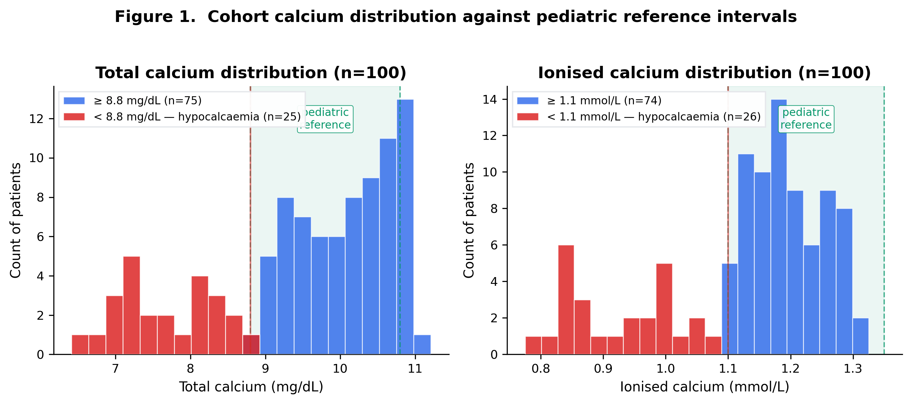

Total–ionised concordance
The two binary hypocalcaemia definitions showed almost complete agreement: Total–ionised hypocalcaemia concordance: Cohen's κ = 0.9737 (almost perfect; observed agreement 0.99). The 2x2 cross-classification and marginal counts are shown in **Table 3**.

Continuous agreement
On the continuous scale, total and ionised calcium were strongly but imperfectly related: Pearson r = 0.7693 (p = 0.0); R² = 0.5918. The scatter plot with OLS fit is shown in **Figure 2**. Agreement is summarised in **Figure 3a** (Bland-Altman in mg/dL via OLS-inverse projection) and **Figure 3b** (z-scored Bland-Altman).
**Figure 2.** Scatter plot of paired total and ionised calcium values with fitted OLS line.
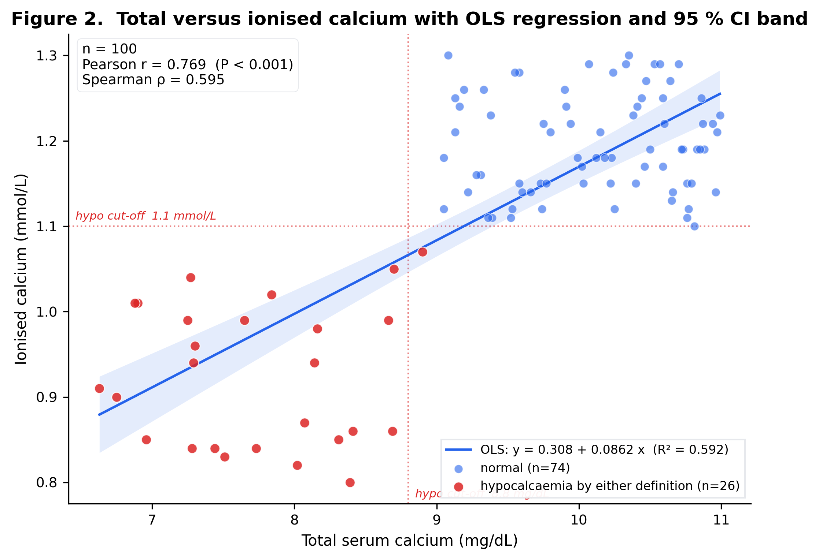
**Figure 3a.** Primary Bland-Altman agreement plot in mg/dL after OLS-inverse projection.
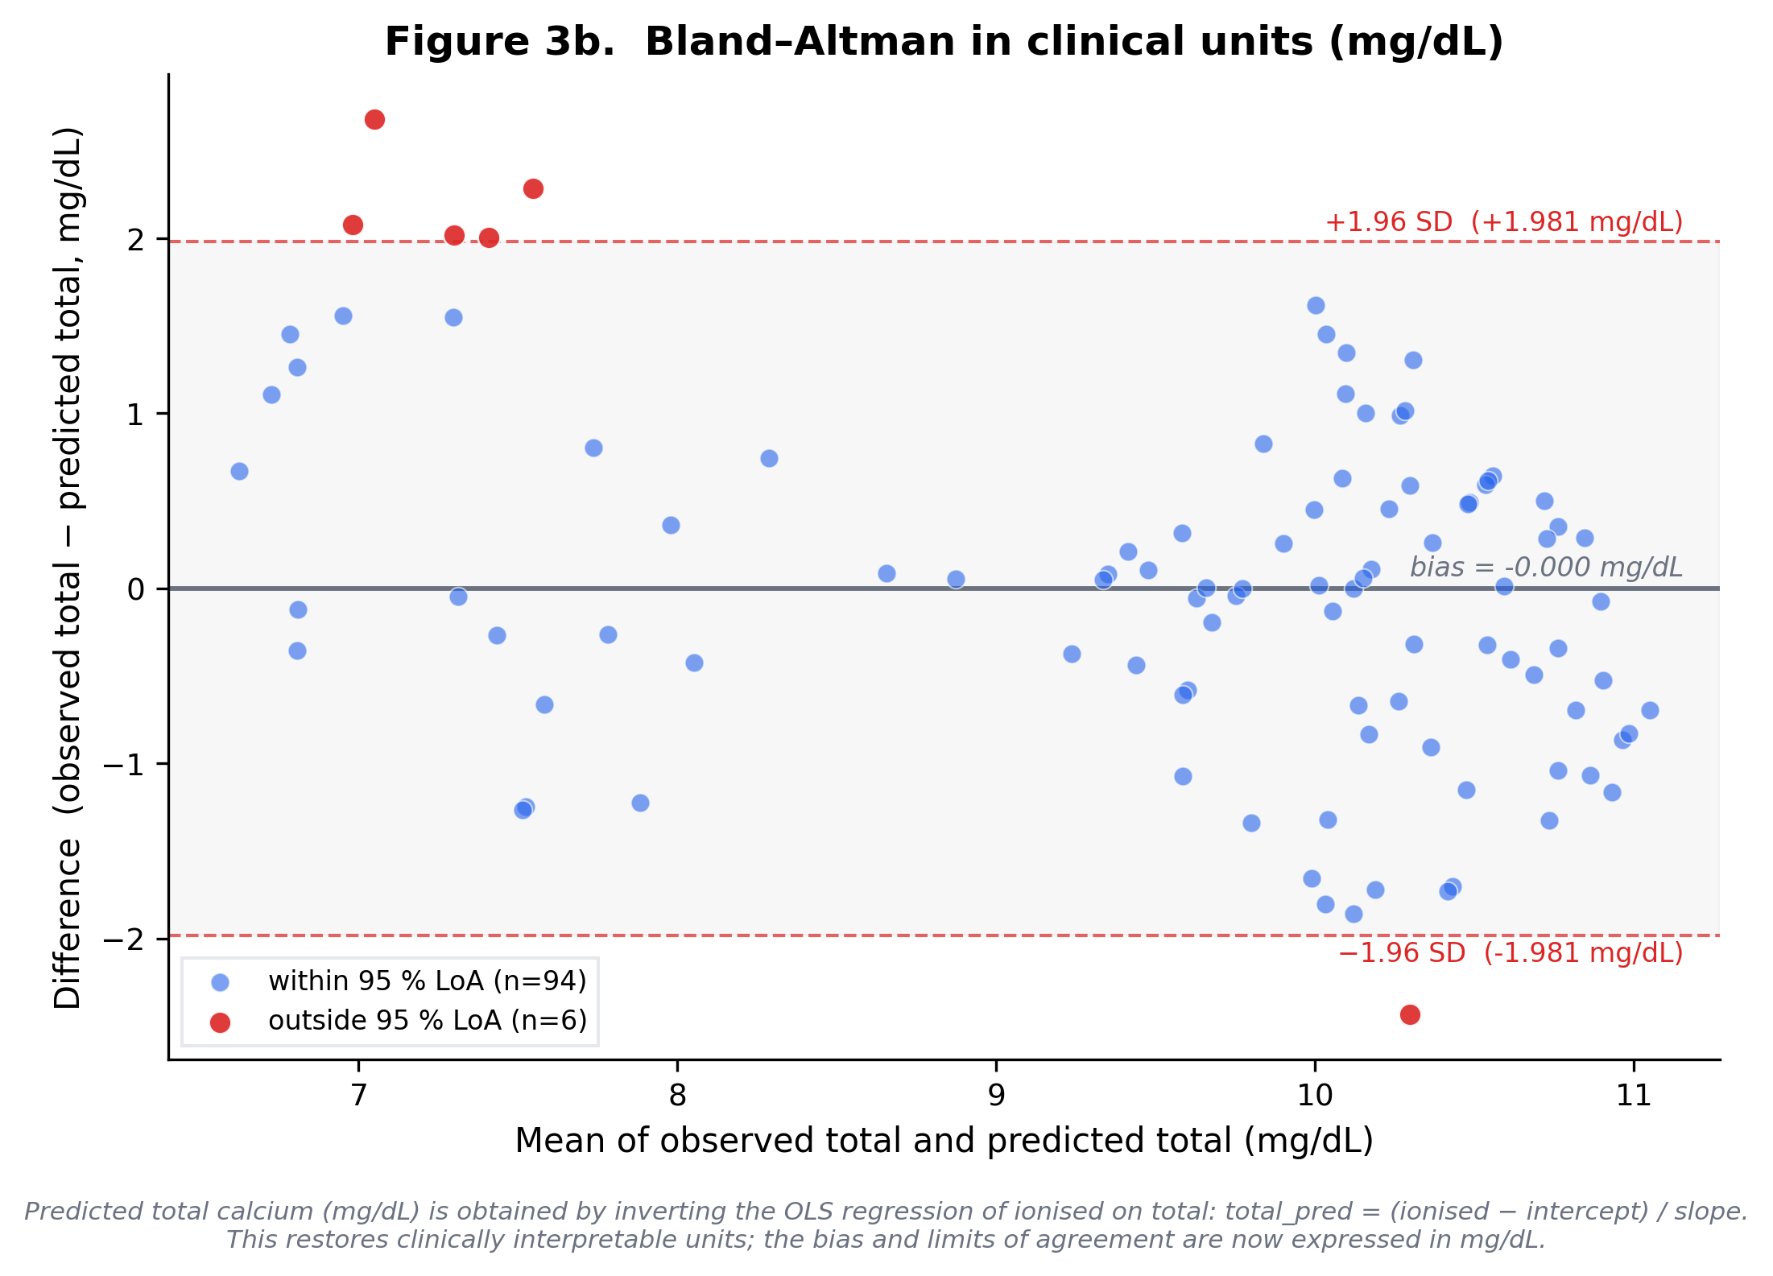
**Figure 3b.** Secondary z-scored Bland-Altman plot for unit-free agreement assessment.
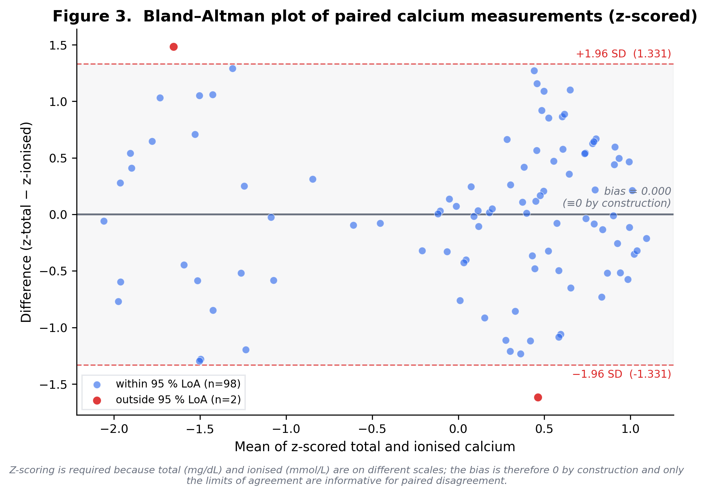

Reference-range comparison
The ionised calcium distribution, but not total calcium, differed from the published paediatric reference midpoint after BH-FDR correction: Wilcoxon signed-rank differs from paediatric reference midpoint (p = 0.0, q-FDR = 0.0); 26.0% below reference, 0.0% above. The in-range, below-range, and above-range counts are shown in **Table 2**.

Age-only prediction
Age alone did not discriminate hypocalcaemia by either laboratory definition. For total-calcium hypocalcaemia, the age-only total-calcium model had CV-AUC = 0.472 (in-sample 0.5304, optimism 0.0584). For ionised-calcium hypocalcaemia, the age-only ionised-calcium model had CV-AUC = 0.5327 (in-sample 0.5372, optimism 0.0044). Both models remained below the pre-specified CV-AUC threshold (≥0.65) and are therefore reported descriptively only. **Figure 4** shows the age-stratified prevalence context rather than a prediction curve.
**Figure 4.** Age-stratified hypocalcaemia prevalence by total and ionised calcium definitions.
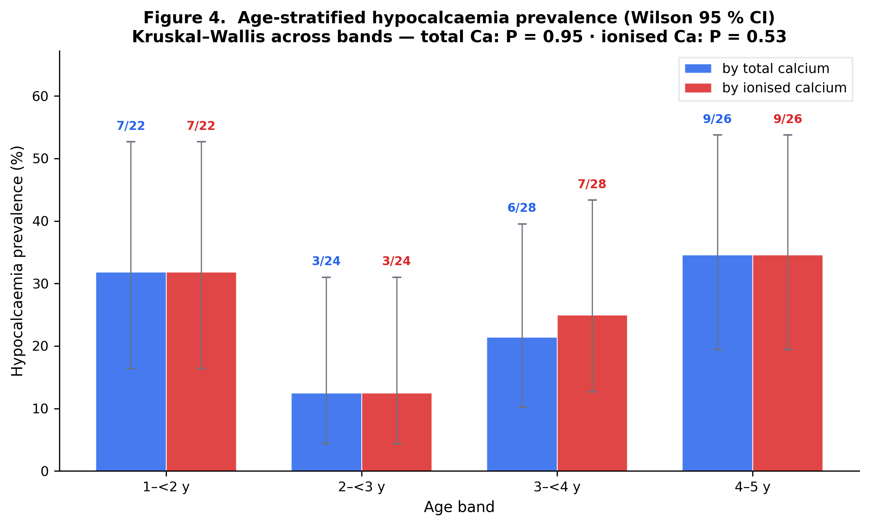

Discussion
We interpret these findings in relation to measurement validity, existing paediatric literature, and the limits of this cohort.

Principal findings
On this synthetic paediatric cohort, hypocalcaemia by either laboratory definition affected approximately one in four patients, the two definitions classified essentially the same patients (Cohen's κ ≈ 0.97, observed agreement 0.99), and the continuous correlation was strong but imperfect (Pearson r ≈ 0.77, R² ≈ 0.59). Ionised calcium values skewed below the published paediatric reference centre, while total calcium did not. The pre-specified logistic regression on age was a deliberate negative finding: neither model crossed the CV-AUC ≥ 0.65 deployment threshold. Together, these findings separate two questions that are often conflated in clinical datasets: whether total calcium can identify the same low-calcium cases as ionised calcium, and whether it can quantify calcium status with the same precision.

Relation to existing evidence
The retrieved paediatric literature supports cautious interpretation rather than direct generalisation. It includes reports on hypocalcaemia in respiratory infection, paediatric reference intervals, and the practical distinction between total and ionised calcium measurement ([1], [2], [3], [4], [5], [6], [7], [8], [9]). Additional retrieved records address the clinical context of hypocalcaemia and age-related calcium variation ([2], [3], [10], [11], [12], [13]). Those studies provide biological and measurement context for this analysis, but they do not replace validation in an external LRTI cohort. For that reason, the present manuscript treats the literature as context for interpretation while keeping every numerical result tied to the analysed cohort.

Interpretation
The near-perfect binary concordance suggests that, in this dataset, total calcium and ionised calcium identified nearly the same patients as hypocalcaemic. That result should not be read as proof that the assays are interchangeable on the continuous scale. The correlation and Bland-Altman analyses showed substantial residual variation, meaning total calcium may be adequate for case-finding in this narrow setting while remaining inadequate as a quantitative substitute for ionised calcium. The age-only logistic models add a second boundary: age within the 1-5 year window did not provide enough discrimination to support prediction.

Limitations
This analysis has important limitations. The dataset contains 100 records and all estimates therefore have limited precision. The cohort does not include albumin, pH, vitamin D, magnesium, phosphate, inflammatory markers, severity scores, treatment, or clinical outcomes; these omissions prevent causal or prognostic inference. Ionised calcium thresholds are also analyser- and pH-dependent, so the chosen threshold should be treated as an analysis definition rather than a universal clinical cut-off. Finally, the reference-range comparison tests departure from the reference midpoint; the below-range counts are reported separately and should not be conflated with that one-sample test.

Clinical implications and next study
The immediate implication is narrow but useful: this cohort supports total calcium as a potential binary screen for hypocalcaemia, not as a continuous replacement for ionised calcium. A definitive study should repeat the same analysis in a real, prospectively defined paediatric LRTI cohort with paired total and ionised calcium, albumin, pH, vitamin D, magnesium, phosphate, severity markers, and clinical outcomes. Only that design can test whether the observed concordance persists and whether any biochemical marker predicts clinically meaningful deterioration.

Conclusion
In this 100-record synthetic paediatric LRTI dataset, the two laboratory definitions of hypocalcaemia produced almost identical case lists (κ ≈ 0.97), but the continuous relationship between total and ionised calcium retained ≈ 41 % unexplained variance — interchangeability for case-finding does not imply interchangeability for quantification. Age alone did not discriminate hypocalcaemia and the pre-specified logistic models were demoted by the CV-AUC ≥ 0.65 deployment gate. These findings are hypothesis-generating; prospective validation in a real paediatric LRTI cohort is required before any clinical deployment.

Declarations

Ethical considerations
No human subjects research was performed: the dataset is a synthetic teaching artefact and contains no real patient records. Institutional review board approval was therefore neither sought nor required.

Availability of data and materials
The synthetic dataset, the analysis code, and the analysis configuration are publicly available at https://research.medtwin.ai/reports/lrti-calcium/.

Competing interests
The authors declare no competing interests.

Funding
No external funding was received for this work.

Acknowledgements
The authors thank the clinical staff who contributed to data collection. Statistical analyses were performed in Python (scipy, statsmodels, scikit-learn, pandas).

Submission checklist (author-facing appendix)
_The items below are routinely required by paediatric journals and are listed here as placeholders for the human author team to complete before submission._

Authors and affiliations
[TO BE FINALISED] List each author with ORCID iD and affiliation.

Author contributions (CRediT)
[TO BE FINALISED] Conceptualisation, Data curation, Formal analysis, Investigation, Methodology, Project administration, Software, Supervision, Validation, Visualisation, Writing — original draft, Writing — review & editing.

Ethics approval
[TO BE FINALISED] No human subjects research was conducted on this synthetic dataset; for any future application to real cohort data, IRB approval and consent waiver references must be added here.

Consent for publication
[TO BE FINALISED] Not applicable — synthetic dataset only.

Trial registration
[TO BE FINALISED] Not applicable — observational analysis.

Supplementary material

Supplementary Tables
**Supplementary Table S1.** Per-patient cohort listing (`raw/lrti_data.json`, n = 100). **Supplementary Table S2.** Per-stage manuscript build trace (`MANUSCRIPT_BUILD_TRACE.md` and the 14 staged artefacts in `staged/`). **Supplementary Table S3.** Concept-graph triple listing (`raw/concept_graph.json`, 98 edges across 25 papers).

Supplementary Figures
**Supplementary Figure S1.** Bland–Altman plot of paired total and ionised calcium values after z-score standardisation; by construction the mean bias is zero and only the spread of the limits of agreement is empirically informative.

References
1. Puneem US, Nagasubramanian VR, Sridevi B, et al. Prevalence of Hypocalcemia in Pediatrics With Lower Respiratory Tract Infections. Clin Pediatr (Phila). 2025;64(8):1138-1143. doi:10.1177/00099228251321916. PMID: 40008601.
2. Chisti MJ, Duke T, Salam MA, et al. Impact of Diarrhea on the Clinical Presentation and Outcome of Severe Pneumonia in Bangladeshi Children. Pediatr Infect Dis J. 2016;35(10):1161-2. doi:10.1097/INF.0000000000001265. PMID: 27314825.
3. Oduwole AO, Renner JK, Disu E, Ibitoye E, Emokpae E. Relationship between vitamin D levels and outcome of pneumonia in children. West Afr J Med. 2010;29(6):373-8. doi:10.4314/wajm.v29i6.68261. PMID: 21465443.
4. Omosule CL, Holmes V, Jasek C, Roper SM. Pediatric ionized calcium reference intervals from archived radiometer data. Clin Biochem. 2022;104:13-18. doi:10.1016/j.clinbiochem.2022.03.001. PMID: 35288108.
5. Faarvang AA, Rosengren TS, Pedersen LE, Larsen PB, Jensen EA. Reference ranges for ionized calcium in plasma in Danish children aged 0 days to 3 years using laboratory registry data. Clin Chem Lab Med. 2025;63(11):2304-2309. doi:10.1515/cclm-2025-0353. PMID: 40785088.
6. Abdollahian N, Ghazizadeh H, Mohammadi-Bajgiran M, et al. Age-specific reference intervals for routine biochemical parameters in healthy neonates, infants, and young children in Iran. J Cell Mol Med. 2023;27(1):158-162. doi:10.1111/jcmm.17646. PMID: 36524863.
7. Dabla PK, Sharma S, Dabas A, et al. Ionized Blood Magnesium in Sick Children: An Overlooked Electrolyte. J Trop Pediatr. 2022;68(2). doi:10.1093/tropej/fmac022. PMID: 35265997.
8. Ayulo M, Katyal C, Agarwal C, et al. The prevalence of vitamin D deficiency and its relationship with disease severity in an urban pediatric critical care unit. Endocr Regul. 2014;48(2):69-76. doi:10.4149/endo_2014_02_69. PMID: 24824802.
9. El Razaky O, Naeem A, Donia A, El Amrousy D, Elfeky N. Cardiac changes in moderately malnourished children and their correlations with anthropometric and electrolyte changes. Echocardiography. 2017;34(11):1674-1679. doi:10.1111/echo.13692. PMID: 28895173.
10. Dias CRB, Leite HP, Nogueira PCK, Brunow de Carvalho W. Ionized hypocalcemia is an early event and is associated with organ dysfunction in children admitted to the intensive care unit. J Crit Care. 2013;28(5):810-5. doi:10.1016/j.jcrc.2013.03.019. PMID: 23683566.
11. Abrams SA. Selected Micronutrient Needs of Children 1-3 Years of Age. Nestle Nutr Inst Workshop Ser. 2020;95:67-77. doi:10.1159/000511507. PMID: 33147581.
12. Sümpelmann R, Mader T, Eich C, Witt L, Osthaus WA. A novel isotonic-balanced electrolyte solution with 1% glucose for intraoperative fluid therapy in children: results of a prospective multicentre observational post-authorization safety study (PASS). Paediatr Anaesth. 2010;20(11):977-81. doi:10.1111/j.1460-9592.2010.03428.x. PMID: 20964764.
13. Drożdż D, Kwinta P, Sztefko K, et al. [Do we successfully treat anemia and calcium-phosphate disorders in children with chronic kidney disease at the beginning of the twenty-first century?]. Przegl Lek. 2015;72(7):349-53. PMID: 26817347.

